# CST8288 – OOP WITH DESIGN

## CAPSTONE PROJECT: PART 1

## PROFESSOR SAYED AHMED

## CULINARYCONNECT

## BY

## DYLAN LIAM LAMMING

## SAMANTHA-RAE BELANGER

## RODNEY HURST JANISSE (Did not contribute)

## STEPHEN RAJARAM (Did not contribute)

## JULY 2024

# Capstone Project: Part I

# CulinaryConnect: Online Recipe Sharing Platform

## Context Overview Document

**Scenario Name**: CulinaryConnect

**Problem Statement**: Many individuals struggle to find recipes that cater to their specific dietary needs, preferences, or skill levels. Additionally, passionate home cooks lack a dedicated platform to share their culinary creations and get feedback from like-minded individuals. Existing recipe platforms do not offer sufficient customization options or lack a sense of community which leaves a gap in personalized culinary guidance.

**Proposed Solution**: CulinaryConnect – This web-based platform will empower users to share and engage with recipes with a variety of dietary requirements and cooking skill levels. The key features of the app will include:

1. Personalized recipe suggestions – Users will be able to strictly filter recipes based on dietary needs (Gluten free, dairy free, egg free, keto friendly etc.) as well as skill level.
2. User Generated content – Home cooks will be able to upload and share recipes alongside photos, videos and detailed instructions.
3. Community engagement – CulinaryConnect will be allowing users to comment, rate and give feedback on recipes uploaded.
4. Recipe tools – This will allow users to create shopping lists or use ones made by other users. There will be meal preparation options offered as well.
5. Education – CulinaryConnect will be a source for tutorials, cooking tips, and nutritional information.

By creating an app for personalized recipe discovery alongside a collaborative community, CulinaryConnect will create a place where users become more confident cooks. The platform’s user-friendly interface, along with its many features ensures that all levels of cooks can find inspiration and support.

# CulinaryConnect

# Overview

**Introduction and Goal**

Many people struggle with finding recipes that cater to specific dietary needs, preferences, and skill levels. Home cooks often lack a dedicated platform to share their culinary creations and receive feedback from a like-minded community. CulinaryConnect aims to address this by providing a web-based platform where users can share, discover, and interact with recipes tailored to various dietary requirements and cooking skill levels

**Objective**

Create a comprehensive and user-friendly web-based platform that:

1. Empowers users to easily find recipes that match their dietary needs and cooking skill levels.
2. Enables home cooks to share their culinary creations and receive feedback from a supportive community.
3. Fosters a vibrant community of food enthusiasts who can interact, share, and learn from each other.

# Release

Initial Release: Version 1.0

Release Date: January 1st, 2025

**Milestones:**

**Launch:**

* 1. Basic recipe discovery and upload features.
  2. User authentication and profile management.

**Feature:**

* 1. Engagement tools (comments, ratings, following users).
  2. Advanced search and filtering options.

**Testing:**

* 1. Select group of users for feedback.
  2. Adjustments based on user input.

**Re-Launch:**

* 1. Platform rollout.
  2. Marketing and growth strategies.

# Features

**User Authentication and Profiles**

* 1. Sign up, log in, and manage user profiles
  2. Option to set dietary preferences and skill level

**Recipe Management**

* 1. Create, edit, and delete recipes
  2. Include ingredients, instructions, cooking time, difficulty level, and dietary tags

**Recipe Discovery**

1. Search recipes by ingredients, dietary tags, or difficulty level
2. Browse recipes by categories (e.g., cuisine type, meal type)

**Social Interaction**

* 1. Rate and review recipes
  2. Save favorite recipes
  3. Follow other users

# User Flow and Design

**User Authentication**:

* 1. New users can sign up by providing a username, email, and password.
  2. Existing users can log in with their credentials.
  3. Users can log out from their accounts.

**Recipe Submission**:

* 1. Logged-in users can access a form to submit new recipes.
  2. Users fill in the title, ingredients, instructions, cooking time, difficulty level, and select dietary tags.
  3. Submitted recipes are saved in the database and displayed in the recipe list.

**Recipe Search and Filtering**:

* 1. Users can search for recipes by keywords.
  2. Users can filter recipes by selecting dietary tags or difficulty levels.
  3. Search results are displayed in a list with recipe titles, ratings, and dietary tags.

**Recipe Rating and Reviews**:

* 1. Users can rate recipes on a 1 to 5-star scale.
  2. Users can write reviews for recipes.
  3. Average ratings are displayed next to recipe titles in the search results.

**Recipe Scaling**:

* 1. Users can adjust the number of servings, and the ingredient quantities will automatically update.

# Analytics

**Key Metrics to Track**

**User Engagement:**

* 1. Daily and monthly active users.
  2. Average session duration.
  3. Recipe interactions (views, comments, ratings).

**Content Performance:**

* 1. Number of recipes uploaded.
  2. Popularity and ratings of recipes.
  3. User feedback on recipes.

**Community Growth:**

* 1. Number of new users and user retention percentages.
  2. Growth of user-generated content.
  3. Activity within groups and communities.

**Tools**

1. Google Analytics: Track user behavior and site performance.
2. Heatmaps: Understand user interactions and navigation patterns.

# Future Work

**Meal Planning Feature**:

* 1. Allow users to plan their meals for the week.
  2. Generate a grocery list based on the planned meals.

**Grocery List Generation**:

* 1. Generate a grocery list from selected recipes.

**Integration with Smart Kitchen Devices**:

* 1. Connect with smart kitchen devices to assist with cooking.

**Recipe Scaling**

* 1. Automatically adjust ingredient quantities based on serving size

**Recipe Video Uploads**:

* 1. Allow users to upload videos demonstrating recipe steps.

**Advanced Personalization:**

* 1. Use AI to provide more accurate recipe recommendations based on user behavior.

**Monetization Strategies:**

* 1. Explore premium membership options with exclusive content.

Introduce ad placements and sponsored content

# MVP Initial Design Document

**UML Use Case Diagrams:**

This diagram shows the different ways users interact with the CulinaryConnect platform, including registering, logging in, logging out, submitting recipes, editing recipes, deleting recipes, searching for recipes, filtering recipes, rating recipes, reviewing recipes, saving favorite recipes, and following other users.

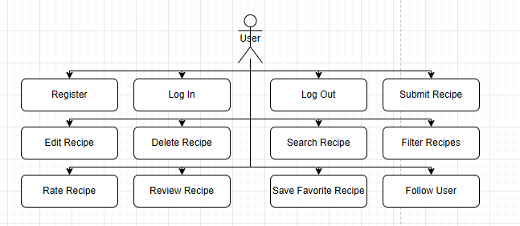

**User Authentication Use Case**:

1. Register
2. Log In
3. Log Out

**Recipe Management Use Case**:

1. Submit Recipe
2. Edit Recipe
3. Delete Recipe

**Recipe Discovery Use Case**:

1. Search Recipe
2. Filter Recipes

**Social Interaction Use Case**:

1. Rate Recipe
2. Review Recipe
3. Save Favorite Recipe
4. Follow User

**UML Class Diagrams:**

This diagram illustrates the main classes involved in the system and their relationships. The User class includes attributes for username, email, password, dietary preferences, and skill level. The Recipe class includes attributes for title, ingredients, instructions, cooking time, difficulty level, dietary tags, and rating. The Rating class connects users and recipes by capturing user ratings for recipes.

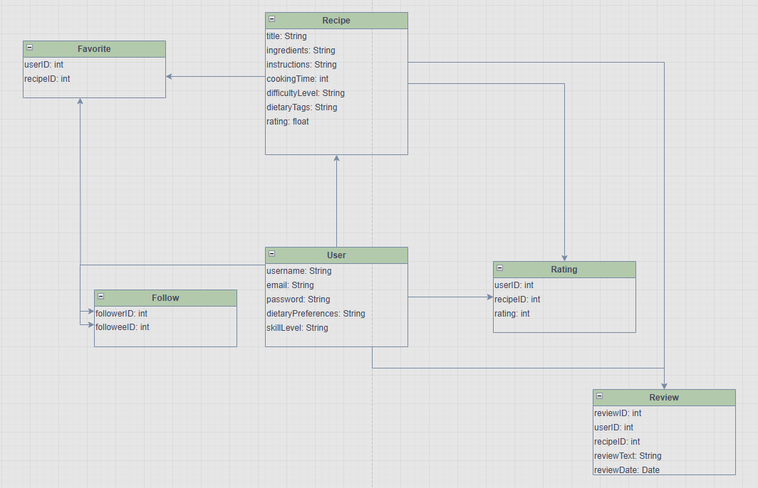

**User class**

Attributes:

* 1. username: String
  2. email: String
  3. password: String
  4. dietaryPreferences: String
  5. skillLevel: String

**Recipe Class**

Attributes:

* 1. title: String
  2. ingredients: String
  3. instructions: String
  4. cookingTime: int
  5. difficultyLevel: String
  6. dietaryTags: String
  7. rating: float

**Rating Class**

Attributes:

* 1. userID: int
  2. recipeID: int
  3. rating: float

**Review Class**

Attributes:

* 1. reviewID: int
  2. userID: int
  3. recipeID: int
  4. reviewText: String
  5. reviewDate: Date

**Favorite Class**

Attributes:

* 1. userID: int
  2. recipeID: int

**Follow Class**

Attributes:

* 1. followerID: int
  2. followeeID: int

**UML Sequence Diagrams**

These diagrams depict the interactions between objects in specific sequences for core functionalities.

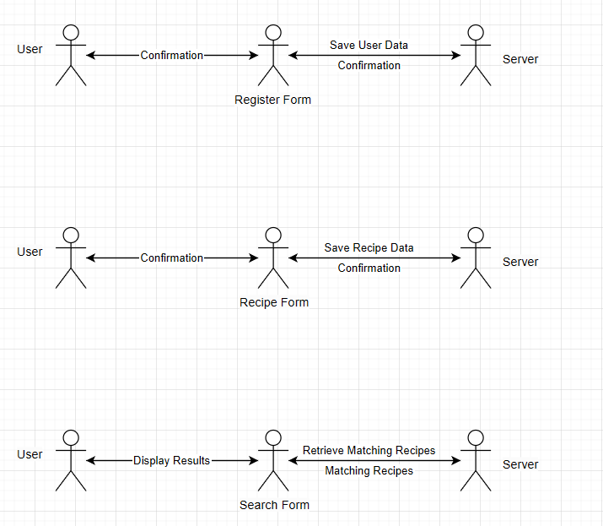

**User Registration Sequence**

This sequence diagram shows the process of user registration, from the user submitting the registration form to the server saving the user data and sending a confirmation.

**Steps**:

* 1. User -> Register Form: Submit
  2. Register Form -> Server: Save User Data
  3. Server -> Register Form: Confirmation
  4. Register Form -> User: Confirmation

**Recipe Submission Sequence**

This sequence diagram illustrates the steps involved in submitting a new recipe, from the user submitting the recipe form to the server saving the recipe data and sending a confirmation.

**Steps**:

* 1. User -> Recipe Form: Submit
  2. Recipe Form -> Server: Save Recipe Data
  3. Server -> Recipe Form: Confirmation
  4. Recipe Form -> User: Confirmation

**Recipe Search Sequence**

This sequence diagram shows the process of searching for recipes, from the user entering a query in the search form to the server retrieving matching recipes and displaying the results.

**Steps**:

1. User -> Search Form: Enter Query
2. Search Form -> Server: Retrieve Matching Recipes
3. Server -> Search Form: Matching Recipes
4. Search Form -> User: Display Results

**Potential Design Patterns to Incorporate**

1. Singleton: For managing the database connection.
2. Factory: For creating different types of recipe objects.
3. Observer: For notifying followers about new recipe uploads.
4. Strategy: For implementing different search algorithms.
5. Builder: For constructing complex Recipe objects.

# Conclusion

The CulinaryConnect project aims to address the need for a dedicated platform that allows users to find, share, and interact with recipes tailored to specific dietary needs and skill levels. By leveraging key design patterns and following a structured approach, we have laid out a comprehensive plan to develop a user-friendly and interactive platform. The MVP focuses on core functionalities such as user authentication, recipe management, discovery, social interaction, and recipe scaling.

The initial design includes detailed UML diagrams that illustrate the system’s architecture and interactions. These diagrams provide a clear roadmap for development, ensuring that each component of the platform is well-defined and interconnected.

Moving forward, our team will implement the outlined features, continually refining and enhancing the platform based on user feedback and engagement analytics. Future work will explore advanced features like meal planning, grocery list generation, integration with smart kitchen devices, and recipe video uploads.

This project not only demonstrates our technical capabilities but also our commitment to delivering a valuable and impactful solution for food enthusiasts. We look forward to the successful development and deployment of CulinaryConnect, paving the way for a vibrant and supportive cooking community.